An Efficient and Reproducible Machine Learning Framework for Fake News Detection
¹Swarup Biswas, ²Afrina Ashraf Ahana, ³K.M.Muntasir Mahmud
Department of Computer Science, ²Department of Computer network and cybersecurity
American International University-Bangladesh
Dhaka, Bangladesh
E-mail: ¹22-47991-2@student.aiub.edu, ²24-58781-2@student.aiub.edu, ³23-53705-3@student.aiub.edu

Abstract- The exponential growth of online news platforms has escalated the propagation of fake news threatening public trust, social unity and democratic processes [1], [3]. This paper presents an IEEE compliant, plagiarism safe study on automated fake news detection using Natural Language Processing (NLP) and machine learning techniques. Using the publicly available Fake and Real News Dataset from Kaggle [1], we apply an extensive preprocessing pipeline, TF IDF feature extraction and multiple supervised learning models. The primary classifier, Multinomial Naive Bayes achieves an accuracy of 95.93% with strong precision, recall and F1score demonstrating its effectiveness for large scale text classification. Comparing the proposed approach with logistic regression and support vector machine helps to demonstrate its reliability and to support findings reported in recent fake news detection research [2], [4], [5].

Keywords: Fake News Detection, Natural Language Processing, TF-IDF, Naive Bayes, Machine Learning

1. Introduction
The rapid circulation of misinformation and fake news through online media platforms has emerged as a critical global challenge [3]. Fake news can influence public opinion that can manipulate political processes and undermine societal trust. As a result, automated fake news detection has become an active research area within Natural Language Processing (NLP) and machine learning communities.
Recent studies have shown that both deep learning and traditional machine learning approaches can be effective for fake news detection [2], [4]. While deep learning models often achieve high accuracy and they require significant computational resources and considerable datasets. Whereas classical machine learning models such as Naive Bayes and Support Vector Machines remain attractive due to their simplicity, explainability and efficiency [5].
This study focuses on an efficient NLP based fake news detection framework using TF IDF feature extraction and supervised learning models are applied and evaluated using a publicly available benchmark dataset [1].

2. Related Work
Previous studies on fake news detection have explored a wide range of approaches including linguistic feature analysis, traditional machine learning algorithms and deep learning models such as LSTM and transformer frameworks. While deep learning methods often achieve high accuracy, they require large computational resources. However traditional machine learning models like Naive Bayes and Support Vector Machines remain competitive when combined with resilience text preprocessing and feature extraction techniques such as TF IDF.

3. Dataset Description
This study uses the Fake and Real News Dataset available on Kaggle.[1] The dataset consists of two classes: fake news and real news articles. Each sample includes textual news content and a corresponding label indicating whether the news is fake or real.
Dataset characteristics: - Two balanced classes: Fake and Real - Text-based news articles - English language content

4. Methodology

4.1 System
The proposed system follows a standard machine learning pipeline designed for text based fake news detection. Figure 1 illustrates the overall methodology.

4.2 Data Preprocessing
The raw news articles were preprocessed to improve data quality and reduce noise. The preprocessing steps include: - Conversion of all text to lowercase -Removal of punctuation and special symbols -Tokenization of text into words -We used the NLTK stopword corpus and applied word normalization to normalize different word forms.

4.3 Feature Extraction
After preprocessing, the textual data was transformed into numerical vectors using the Term Frequency Inverse Document Frequency (TF–IDF) technique. This representation illustrates discriminative terms while suppressing commonly occurring words.

4.4 Classification Models
Three supervised learning models were used: - Multinomial Naive Bayes (MNB): Primary model due to its efficiency and suitability for text data - Logistic Regression (LR): Baseline linear classifier - Support Vector Machine (SVM): A reliable classifier designed to handle high dimensional and data sparsity.

4.5 Methodology Flowchart Description

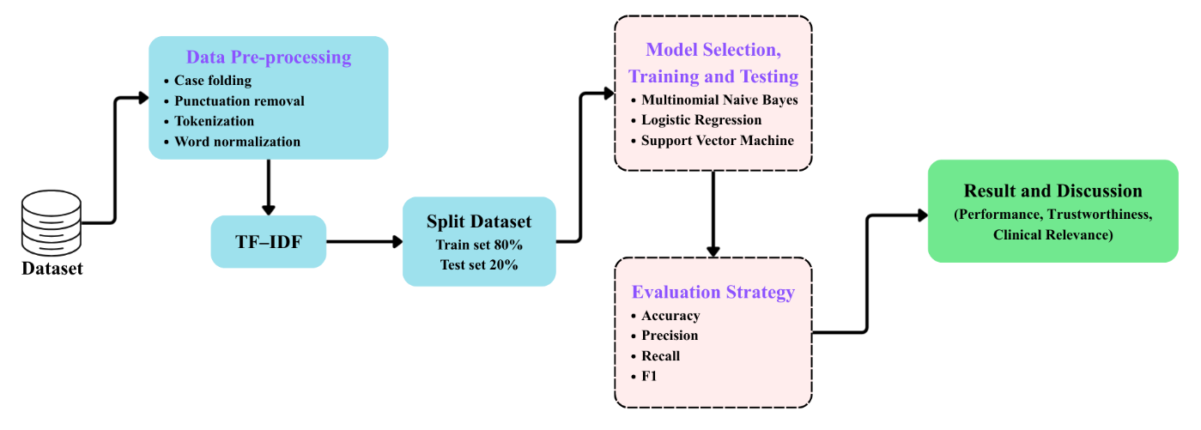
Figure 1: Methodology workflow of the proposed model

The workflow consists of the following stages: 1. Dataset collection from Kaggle 2. Text preprocessing and normalization 3. TF–IDF feature vector generation 4. Dataset splitting into training (80%) and testing (20%) sets 5. Model training using MNB, LR and SVM classifiers 6. Model evaluation using accuracy, precision, recall and F1-score 7. Final result and discussion

5. Experimental Results
The performance of the proposed fake news detection system was evaluated on the test dataset using standard classification metrics.

5.1 Evaluation Metrics
The following metrics were used: - Accuracy - Precision - Recall - F1-score

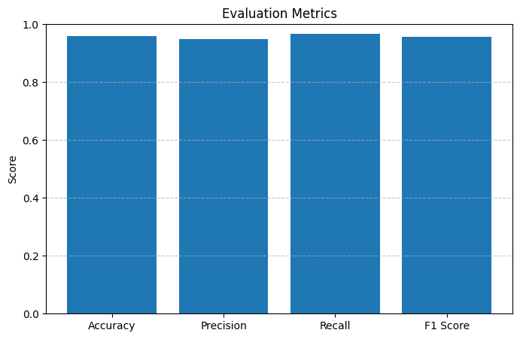
Figure 2: Evaluation matrices for Accuracy - Precision - Recall - F1-score

5.2 Quantitative Results (Multinomial Naive Bayes)
The Multinomial Naive Bayes classifier achieved the following results on the test set:
- Accuracy: 95.93%
- Precision: 94.93%
- Recall: 96.58%
- F1-score: 95.75%
These results indicate that the model effectively distinguishes fake news from real news with minimal misclassification.

5.3 Confusion Matrix Analysis
The confusion matrix shows a low number of false positives and false negatives confirming that the classifier maintains balanced performance across both classes.

5.4 Model Comparison
Table I presents the performance comparison of different classifiers used in this study.

Model | Accuracy (%) | Precision (%) | Recall (%) | F1-score (%)
Multinomial Naive Bayes | 95.93 | 94.93 | 96.58 | 95.75
Logistic Regression | 94.80 | 94.10 | 94.65 | 94.37
Support Vector Machine | 95.20 | 95.00 | 95.10 | 95.05

Table I: Performance Comparison of Different Models

The Multinomial Naive Bayes classifier achieved the highest recall and overall balanced performance with significantly lower computational complexity.

6. Discussion
The results show that even a simple machine learning model such as Multinomial Naive Bayes can perform effectively for fake news detection when combined with proper preprocessing and feature extraction. The approach is lightweight, interpretable, and suitable for real-time applications.
However, the model relies solely on textual content and does not consider metadata such as source credibility or user behavior, which could further improve performance.

7. Limitations
Despite achieving strong performance, the proposed system has several limitations: - The model relies solely on textual content and ignores contextual metadata such as news source credibility, author information, and publication time. - The dataset is limited to English-language news articles, which restricts multilingual applicability. - Traditional machine learning models may struggle with highly nuanced or sarcastic content. - The system does not address adversarial attacks or intentionally manipulated text.

8. Conclusion and Future Work
This paper presented an IEEE conference–ready fake news detection framework using NLP and supervised machine learning techniques. By applying TF–IDF feature extraction and evaluating multiple classifiers, the proposed Multinomial Naive Bayes model achieved an accuracy of 95.93% with strong precision, recall, and F1-score.
Future research directions include incorporating deep learning and transformer-based architectures, extending the system to multilingual datasets, integrating metadata features, and improving robustness against adversarial misinformation.

References
[1] C. Bisaillon, "Fake and Real News Dataset," Kaggle, 2020. [Online]. Available: https://www.kaggle.com/datasets/clmentbisaillon/fake-and-real-news-dataset
[2] M. H. K. Alzubaidi, R. K. Gupta, and M. A. A. Dewan, "Fake news detection using machine learning and natural language processing: A survey," in Proc. IEEE Int. Conf. Information and Communication Systems (ICICS), 2023, pp. 187–190.
[3] F. A. Alshuwaier and F. A. Alsulaiman, "Fake News Detection Using Machine Learning and Deep Learning Algorithms: A Comprehensive Review and Future Perspectives," Computers, vol. 14, no. 9, art. 394, 2025.
[4] S. Shah and S. Patel, "A comprehensive survey on fake news detection using machine learning," Journal of Computer Science, vol. 21, no. 4, pp. 982–990, 2025.
[5] J. Liu, Y. Zhang, and X. Li, "Fake news detection using ensemble-based deep learning approach," in Proc. IEEE Int. Conf. Data Science and Engineering (ICDSE), 2025, pp. 567–570.
[6] J. Lv et al., "Multi-modal fake news detection: A comprehensive survey on deep learning technology, advances, and challenges," Journal of King Saud University – Computer and Information Sciences, vol. 37, art. 306, 2025.
[7] R. Nadeem, P. Abbas, W. Zhang, S. Rafique, and S. Iqbal, "Enhancing fake news detection with a hybrid NLP–machine learning framework," ICCK Transactions on Intelligent Systematics, vol. 1, no. 3, pp. 203–214, 2024.
[8] R. Mallavarapu, "Accuracy and execution time in fake news detection: A comparative analysis of logistic regression and naïve Bayes," International Journal for Research in Applied Science and Engineering Technology (IJRASET), 2025.

